### DESIGN PROJECT REPORTS OF E-LEARNING PLATFORM

### I-sharing

Group Five——We Are One

|  |  |
| --- | --- |
| Member | Contributions (each person weights 20%) |
| Chen Yayun | Responsible for the eighth and fifth parts of the document, the course page in the prototype design, the course discussion page, and the image replacement and partial improvement of the home page, portfolio and personal center repeater. |
| Wang Xi | Responsible for the fourth and ninth parts of the document, collecting materials, designing logo and UI, the personal center page, as well as the four sub-pages of "my post", "management work", "course group" and "message notification", and participating in the prototype modification. |
| Nie Jing | Responsible for the sixth and seventh parts of the document, the public discussion page, discussion details page in the prototype, design and collect some materials to help the home page improvement and integrating and modifying this final project report documents finally. |
| Fang Wenbo | Responsible for the first, second and third parts of the document, the portfolio page in prototype design. I am the technical support of our team, and I finish all the interactive functions of the interface, including filtering, thumb up, page jumping, time reading, and some UI interface beautification and modification. |
| Wei Yaojia | Responsible for the final design and conclusion of the document. In the prototype design, I was responsible for the realization of homepage, login page and user registration page. And complete most of the interaction and material design for this paging surface. Participate in the modification. |

January 1st, 2020

*Abstract*

This platform is aimed at all students of east China normal university. In order to improve their professional skills, students can integrate works uploaded by students of different grades. Students can communicate with other students and teachers online based on their works or a certain course, so as to improve their professional abilities through sharing and interaction. The survey shows that most participants have a good experience with the platform. If they can choose independently, their willingness to continue using the platform reaches above 7. In general, the platform has a certain promotion value.

# 1.0 Introduction

At present, in view of the endless emergence of systems and papers of homework management and educational administration in colleges and universities, using "homework management" as the key word to search on the China knowledge Network, there are 138 results, with "work management" as the title. The search results have been reduced to 21. It mainly includes the design of different types of work management systems, such as art works management (Zhang Jingchan, 2019; Luo Shaojun, 2015), Flash works management (Guo Qingchun, Hou Cuiping & Sun he, 2012), multimedia works management (Liu Zhong & Zhu Haibin, 1998) and so on. Among them, the main functions of the management platform focus on the upload, submission and evaluation of works, and its main purpose is to assist teachers to manage students' homework and evaluate the works. This kind of work management system makes it more convenient for teachers to manage students' homework and for students to submit homework, but for students, students cannot see the works of other students (unless the teacher is operating in the background to disclose students' works). Nor can you see the work of the previous student studying this course. As far as students are concerned, if they can watch some sample works before doing the works, their thinking can be inspired and the integrity of their works can be improved. Therefore, the "resource sharing platform" we designed provides a platform for students to read each other's works and learn from each other.

The original idea for the design of the product, because we are doing at the start of the mission of each course, to do things without the concept of a global, don't know the need to present what, what needs to be done in the process, the teacher speak in class alone requirements will not be able to let us fully build the understanding of the task as a whole, so if you have the previous sample, the works of senior can help our understanding of the task, can also be designed to provide ideas for our works. Therefore, we want to design such a platform to support students to learn from each other. At the same time, combining the advantages of DaXia learning platform and supporting teachers to manage students' homework, evaluation, discussion and grading, we designed this work.

## 1.1 viewing and browsing the works of previous students

This platform mainly targets students, aiming at students' demand for learning and browsing the learning works of the last course, so that students who apply for corresponding courses can browse the works of students of the last course to facilitate learning and reference.

## 1.2 discussion and reply

On this platform, students can directly ask the author questions in the discussion area below the works after viewing the works of previous students, providing a channel for mutual communication. At the same time, the platform's discussion and reply reminders will be displayed in the campus enterprise account of east China normal university, so that the respondents can see the message and reply in time. Improve the efficiency of the platform. At the same time, there will be opinion leaders in the discussion area according to the quality of the replies.

## 1.3 recommend

Even if students do not apply for certain courses, they can browse the works of the courses they are interested in. Based on the user's browsing record, the recommendation bar on our homepage will also provide corresponding works recommendation.

## 1.4 evaluation and scoring

This platform is compatible with the functions of the homework management platform, which supports the uploading, viewing, teacher scoring, student thumb up, collection and attention of works.

# 2.0 Customer Needs Assessment

As shown in table 1, according to the data such as interview survey, we listed the needs of users. For students, there is indeed a need to view previous seniors' senior works, and it is better to download the learning works and discuss and communicate through this platform. For those who do not understand, they can ask questions from the author, and it is better to get a timely reply from the author. In the survey, users have a great demand for timely reply to the platform's discussion function, which can meet learners' demand for problem-solving in mutual learning. That makes it all the more important to encourage the responses of the people being asked, and to reward them. Students also have a great demand for teachers to answer questions in the platform. In the interview, we learned that teachers' active participation can also stimulate students' enthusiasm for learning. For teachers, the main demand for this platform focuses on the collection and grading function of homework. Therefore, the convenience of browsing works and the demand for adding, deleting, modifying and grading works are the main purposes for teachers to use this platform.

**Table 1. Initial Customer Needs List Obtained from Interviews and Observations**

|  |  |
| --- | --- |
| The students. | The teacher. |
| Quick and convenient browsing works upload works write a short introduction.  Quick and convenient browsing works  Download learning works for interactive discussion.  Personal space for writing learning notes.  Respond promptly.  Teachers' active participation and active participation.  News feeds or links.  Incentives. | Quick and convenient browsing works  Get a brief description of the uploader and the author.  Download the works.  Delete the work  Interactive discussion. |

# 3.0 Revised Needs Statement and Target Specifications

At first, I just wanted to build a platform for sharing course works. However, according to the needs of users, I found that there was a large demand for learning on this platform, especially for the discussion board function under the works. Therefore, we refined the function of discussion board.

In order to ensure the timeliness of the reply, we designed the reply prompt in the discussion area and theWeChat enterprise account of ecnu to establish a link. Through the link with social media, the timeliness of community discussion in the platform can be enhanced. In addition, the incentive mechanism to promote response also needs to be considered. By reading the literature found that opinion leaders in the development of the virtual learning community play an important role in the (2018) mist of history, as a result, according to the comments of thumb up and review score of the teacher, we in the discussion area high quality answer the user defined label, at the same time to motivate students in the discussion of learning from each other.

Depending on the type of work, the types of work that the platform supports online preview need to be further expanded to meet the needs of users to be able to browse the work smoothly.

# 4.0 External Search

## 4.1 Benchmarking

The e-learning platform mainly uses network technology to establish a virtual learning environment that supports and manages the teaching process; provides shared learning resources and various learning tools; digitally represents teaching content; and stores, processes, transmits and presents the information of text, graphics, sound, video. Users can use resources through human-computer interaction to support teachers' teaching and students' learning. The system provides management of learners, teachers and other users; creation, storage and distribution of online courses; and support tools for online learning processes. The development of the function of the e-learning platform has experienced four basic stages:

The first stage: content management systems (CMS). In the early days of the development of network technology, some universities, companies, and training institutions have specially developed to store and manage teaching resources, thereby reducing expenses and enriching the transmission of knowledge. However, its function is limited to resource management. Teachers publish, share, and manage teaching resources through the network. It is only a one-way communication mode of teaching. It lacks two-way interaction, resource formats and management technologies are not unified, and it is difficult to share widely.

The second stage: learning management systems (LMS). LMS originates from the training automation system and has functions such as user registration management, courseware directory management, and learner information data recording. It mainly consists of user management, learning content management, system management and other modules, and generally does not have the function of teaching content production.

The third stage: Learning content management systems (LCMS). The development version of the traditional courseware management system is designed to help teachers or resource experts without technical experience to design, create, publish and manage online courseware, such as well-known teaching platforms blackboard. At the same time, it has functions such as user management and learning progress tracking, which can track the learning progress of students and adjust in time to meet the needs of learners, making it possible to share learning content and interact with the teaching system.

The fourth stage: web-based instruction platforms. Web-based instruction platform ranges from the production and distribution of courseware, teaching organization, teaching interaction, learning support, and teaching evaluation, to the management of users and courses, and the online teaching resource library. It integrates the main functions required by network teaching and forms a relatively complete supporting environment for e-learning.

Among the current e-learning platform, we have selected several representative websites for comparison.

**Table 2.** **Roles and relationships of Platforms**

|  |  |  |  |  |  |
| --- | --- | --- | --- | --- | --- |
|  | | **MOOC** | **ChaoXing** | **DaXia Platform** | **Canvas** |
| Roles and relationships | platform role | Teachers  Students | Teachers  Students | Teachers  Students  Guests | Teachers  Students  Parents (observer) |
| Curriculum role | Teachers  Students  Assistants | Teachers  Students | Teachers  Students  Assistants  Guests  Content builder  Grader  Space creator | Teachers  Students  Assistants  Observers  Designers |
| relationship | Register  College certification | Certification | Teachers invited  Educational administration system import | Register |

**Table 3. Courses and resources of Platforms**

|  |  |  |  |  |  |
| --- | --- | --- | --- | --- | --- |
|  | | **MOOC** | **ChaoXing** | **DaXia Platform** | **Canvas** |
| Courses and resources | Course organization | Teachers upload | Educational administration system import | Educational administration system import | Set license (private, public, commercial, non-commercial) |
| Resources sharing | None | Recommend books, periodicals, lectures and other learning resources | Shared folder | Shared folder  External resources |
| Resources type | Course video  The courseware | Text | Text  Web link  Local document  video | Text  Web link  Local document  video |

**Table 4. Interactive activity of Platforms**

|  |  |  |  |  |
| --- | --- | --- | --- | --- |
|  | **MOOC** | **ChaoXing** | **DaXia Platform** | **Canvas** |
| Interactive activity | Announcement  Discuss  Evaluate the courses  Teacher answer questions | Group  Curriculum chat  Notes | Announcement  Discuss  E-mail  Group  Collaboration  Blog  Log | Announcement  Discuss  E-mail  Real-time meeting  Collaboration  Community |

**Table 5. Evaluate and learning analysis of Platforms**

|  |  |  |  |  |  |
| --- | --- | --- | --- | --- | --- |
|  | | **MOOC** | **ChaoXing** | **DaXia Platform** | **Canvas** |
| Evaluate and learning analysis | Evaluate | Test  Homework  Exam | Attendance  Homework  Exam | Survey  Test  Homework  Self-evaluation and mutual evaluation | Attendance  Test  Homework |
| Learning analysis | None | Record learning behaviors | Course report  Learning behavior management (missed deadlines, score alerts, activity alerts, visit alerts)  Grade indicator board | Active  Submission  Performance analysis  Student analysis |

In addition, I selected Canvas and Daxia Platform for functional analysis, and the results are as follows:

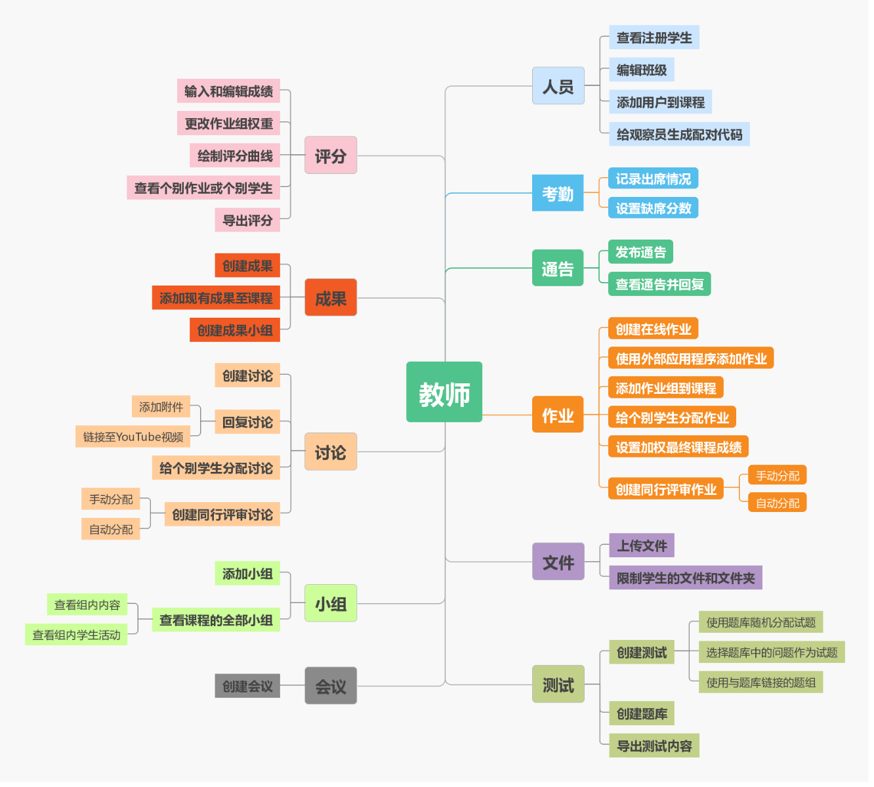

**Figure 1. Functions of Canvas(teachers)**

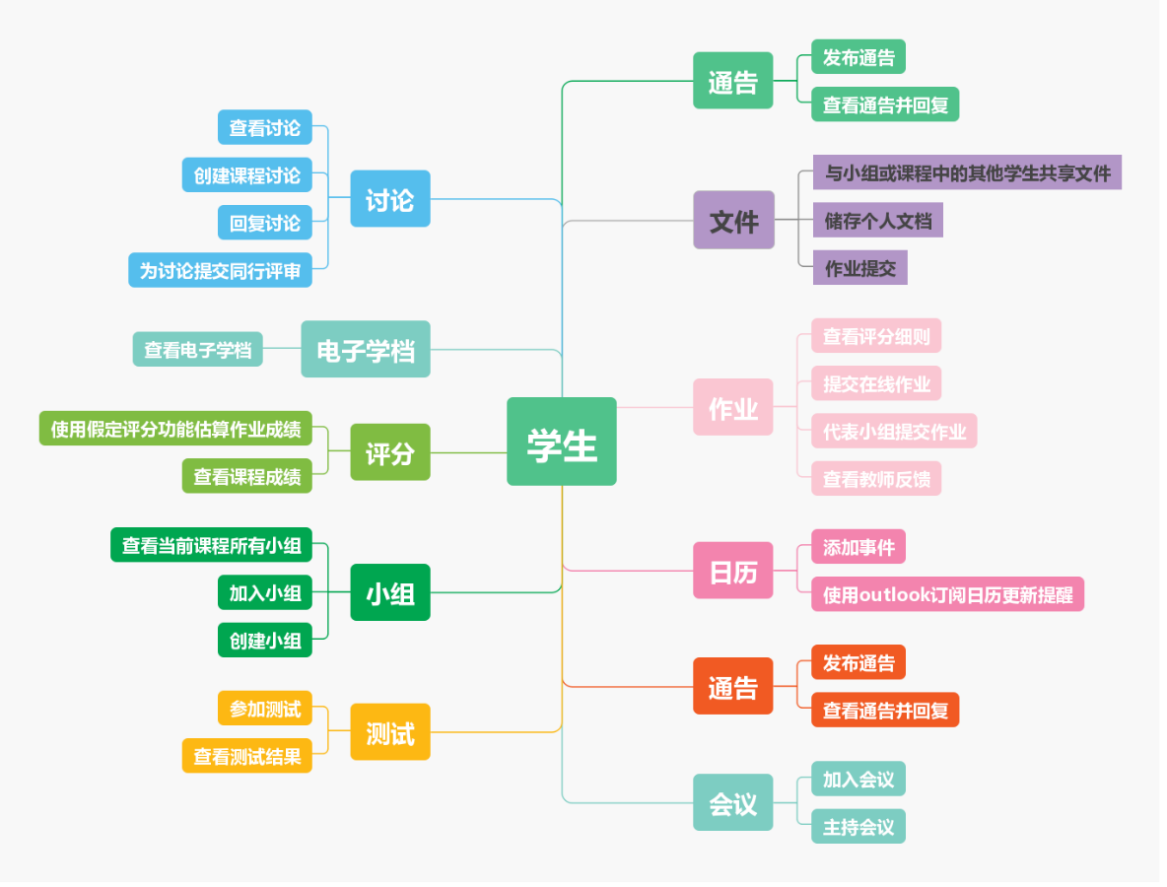

**Figure 2. Functions of Canvas(students)**

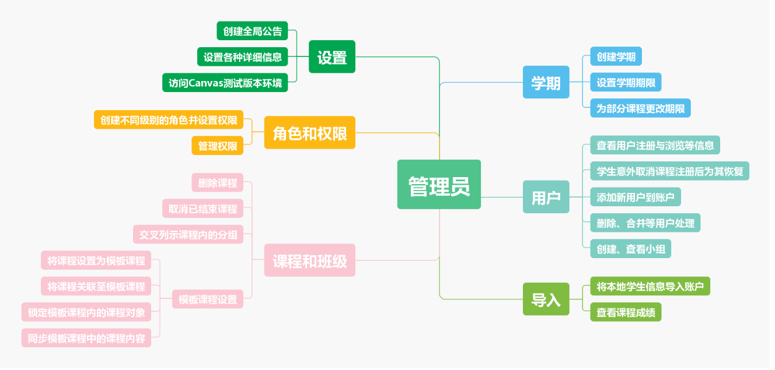

**Figure 3. Functions of Canvas(administrator)**

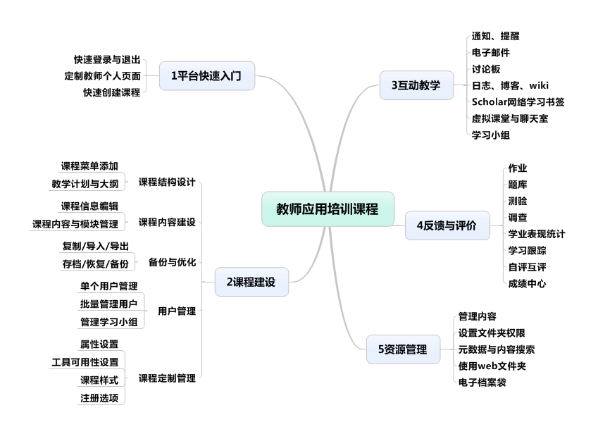

**Figure 4. Functions of DaXia Platform**

According to the above analysis, it can be found that establishing a role is a good way to organize relationships. We intentionally added the role of "Opinion Leader". When the number of users' posts or interactions reaches a certain level, the role can be obtained, and added corresponding user permissions. Users can be different roles under different topics. In these four platforms, the upload of courses or resources mostly depends on the teacher or the system itself, and for college students, they also have the need to obtain the works of the seniors. Therefore, in the platform we designed, resources can also come from previous works, and the types of resources are also diverse to meet the needs of different students.

The core of e-learning includes two aspects: interactive activities and personalized learning. Personalization is the ultimate goal of e-learning, and interactivity is the main way and means of e-learning. E-learning is not only to use multimedia technology to present traditional teaching content and realize teaching resource sharing through network technology, but to return to the essence of teaching and learning. Personalization and interactivity are the soul of the e-learning platform, which embodies the advantages of network education.

Well, in the interactive activities designed by our platform, it is not the richness of the activities, but the enhancement of user stickiness. As for the "discussion" function, it is necessary to increase the real-time communication function, so that the user's communication is like “chat”, real-time and natural. What’s more, learning analysis depends on artificial intelligence technology. In the four platforms, the learning analysis failed to achieve the position. Some of them only stayed at the stage of pure data information presentation, did not continue to mine the information behind the students, and made student behavior prediction. Our platform hopes to make a breakthrough in this regard, to analyze based on behavioral data left by users, to provide learning reports and personalized recommendations.

In general, our platform hopes to achieve: First, personalization. Including platform functional appearance customization, personalized evaluation of student assignments, personal calendar or progress viewing, etc. Second, socialization. Including discussion and communication, interactive tools, and the full application of community networks. Third, intelligence. It is mainly reflected in the student's track record, friendly navigation/help function, and intelligent information retrieval.

## 4.2 Applicable Constraints

The first is constraints of use environment. We need to consider that our targets are college students and graduate students, and we need to understand the basic information of users, their preferences, and the environment they use. This part of the information largely determines our interface layout and style, language, etc.

The second is the constraints of construction environment, that is, constraints from developers and upgrade maintenance personnel. This includes consideration of the technical level of the development team, development management and subsequent maintenance. This is indeed a big challenge for us, so we are more like a "designer" and have developed high-fidelity models.

Third, it is the constraint of technical environment. For example, whether the artificial intelligence technology listed above can be realized under the current circumstances. We have fully considered this factor, and the specific technical implementation will be explained in Chapter 7 and 8.

Finally, it is the constraint of business environment. This involves restrictions on product launch time, budget, laws and patents. Since this platform has not yet entered the development stage, the impact of this part has not yet played a role.

# 5.0 The KIEBIE analysis of you learning platform

## 5.1 Environment

At present, we have only designed the PC web page prototype, which is a web application. Since we have not made an adaptive design, we need to access this platform on the PC side.

## 5.2 Knowledge，Skills，Attitude

This product can provide a platform for students to display their own works, browse and watch works of peers, download and learn works of others. The main purpose is to increase students' interest in making works, to improve their professional skills, and to promote and improve each other in a collaborative learning way.

Knowledge: platform based on the works or post and the other students and teachers through the discussion forum to discuss and browse the recommendation of outstanding works, learn to learn from others' comments, opinions and work to the new knowledge, understand determine which comments and window can be adopted, in order to promote the optimization of themselves in this work, and the next works better.

Skills: through the communication with others and the browsing of recommended works, I can master some work processing skills and improve my communication skills with others.

Attitude: break the gap between grades through the platform, promote communication and sharing among grades, and create different sparks of thinking. The incentive mechanism of the platform can induce students to think and discuss positively, stimulate learning motivation, and cultivate students' ability to communicate and view dialectically.

## 5.3 Behavior and mental process&status

Through my own posts, I can exchange ideas with others, browse others' works, make comments and Suggestions on others' works, point out others' excellent points and actively record them, and at the same time, I can also comment on their shortcomings and optimize their ideas. Through such exchanges, gradually improve the user viscosity of platform to discuss and make the discussion of the user number, thumb up number increase, get more senior role, and is keen on the platform for discussion and doing thinking and communicating with people, at the same time some incentives such as integral rise in return for material reward, will also improve the enthusiasm of students learning and construction works.

## 5.4 Interaction

It is mainly through students' uploading of works, teachers and students' evaluation of their works (focusing on the interaction in the discussion area), so that students can learn/learn some new knowledge and skills about the course (some knowledge and skills not previously known to them) from the comments and discussions. Involving interactions, including the definition of students about their work, to reply the comments of others, thumb up and adopted (or collect comments, in idea, has yet to realize functions of comments collection), as well as within one week after the end of the job submission to oneself the self-reflection of the job evaluation is also present in the discussion area, work and reflection in the same place, can more intuitive know their own a little and the insufficiency, and to browse and view the hot or outstanding or the latest works etc.

## 5.5 Experience

Students through uploading, browse, download, evaluate and communicate with teachers and students, make yourself every work can get more feedback (post), for students to further thinking and learning, close contact with teachers and other students, on the platform get a rich learning engagement and deeper commitment, through online communication, enables the student to the window of more detailed study of excellent works of others, a more open communication, not affected by the space constraints, make up for the offline because of class or student character causes some works couldn't be show.

## 5.6 Interact Object

All students (including graduates), teachers, platform works, posts

## 5.7Initial Screening for Feasibility and Effectiveness

The platform broadens the width and depth of communication in the classroom, and provides feedback and answers to students' doubts and achievements through works or personal question-oriented posts and comments, thus promoting the improvement of personal knowledge and skills. In terms of technology, we use JSON format to transmit data and build an LRS storage statement based on the xAPI specification as a reference for the data structure. For the record of learning experience, we can communicate with senior students who have tried to write papers in this way, so it is feasible to extract data. As for the appearance of the platform, Axure was first used for prototype design, and then HTML + CSS +JS was used to complete the layout design of the platform after modification and finalization.

# 6.0 Learning Theory

## 6.1 What learning theory do you mainly apply

The Humanism Learning Theory was applied in this platform, which believes that humans have a natural tendency to learn and own an inherent potential for learning. Human learning is a spontaneous, purposeful, and selective learning process (Defu Hua,2014). Therefore, from the perspective of humanistic learning theory, the learner is a purposeful person who can choose and shape his behavior and be satisfied with it (Xihua Pan,2017). The task of teaching is to create a situation that is conducive to the development of students 'learning potential, so that students' potential can be fully exerted. Based on this, humanistic learning theory proposes meaning learning, which is not only a study involving the accumulation of facts, but also a study that causes significant changes in individual behavior, attitude, personality, and future choices of action(Li Su,2019). From this we can see that the learning based on humanistic learning theory is not only the acquisition of knowledge, the acquisition of behavior, but also mastery of the learning methods, which are acquired in the process of thinking and reflection. Students actually participate in learning activities to conduct self-discovery, self-evaluation, and self-learning. Only by evaluating and creating can they gain valuable and meaningful experiences and gain methods or experiences on how to learn. About Humanism Learning Theory, representative views are Maslow's "Self-Realization Theory" and Rogers' "Unsupervised Teaching". They emphasized the importance of personal experience and growth, and paid attention not only to the development of cognition in teaching, but also to the cultivation of mentally healthy and creative people as the purpose of education(Gang Lei,2010). Rogers proposed a brand-new "student-centered" educational thought, that is, "non-guided teaching". He believes that "each student is his own" master ", and the teacher's role is to promote learning rather than cause learning to occur." The role of teachers is to induce and guide learning. Only through their own efforts can students make real learning.( Chi Zhang, Haiye Liu, Chenxi Lian, et al,2019)

## 6.2 Why do you apply this theory?

Firstly, this theory stressed that human learning is a spontaneous, purposeful, and selective learning process. And our platform, which will provide students support for learning and browsing prior works , they can choose what they tend to learn on purpose as long as there are abundant resources meeting their requirements.

Besides, humanistic learning theory proposes meaning learning, which is not only a study involving the accumulation of facts, but also a study that causes significant changes in individual behavior, attitude, personality, and future choices of action. Most knowledge is acquired in the process of thinking and reflection. Therefore, the platform provides the conditions for students to realize meaningful learning. Compared with other resource sharing platforms, the platform focuses on the communication among different learners. Through the functions of comments, replies, thumb ups, and scoring on the discussion board, the platform can deepen students' understanding of knowledge and promote their meaning construction, and reflects on the shortcomings of their own works, so as to further improve the quality of his works and create more excellent finished products.

Finally, the theory put forward a concept of non-guided teaching and the teacher's role is to induce, guide and promote learning rather than cause learning to occur. In this platform, teachers have some rights for adding, deleting, modifying and grading works. They can help to improve the quality of resources on the platform instead of getting involved in students’ discussions and evaluation constantly.

# 7.0 Technology applying

## 7.1 Adaptive recommendation

According to the traces of students' access to resources, the frequency of discussions with their learning peers, and user tracking data, identify recent visits, classify learners according to study groups, and implement personalized recommendations. When the user logs in, the dynamic part of the homepage will present the resource content recommended by the system that may meet the needs of the user, so that the user can quickly select the information needed for positioning.

The implementation of the entire technology is divided into two stages of modeling and recommendation(Xiaoxue Liu,2012). In the modeling stage, the learning knowledge is used for modeling. The knowledge model is represented as a series of weighted access learning object constituent vectors, that is, the visited learning object or course element that the learner is interested in. There are two main modeling methods: collaborative modeling and automatic modeling. Collaborative modeling requires learners to provide accurate personal preferences and needs information (ie, explicit feedback). The automatic modeling is based on the learners' online behavior (that is, implicit feedback) to automatically collect information, and continuously collect a large amount of data from the learner interaction and browsing history to automatically submit it to the server or e-Learning system database. The data must be pre-processed by data cleaning, user identification, and session identification in order to effectively use Web mining technology to analyze and model; in the recommendation phase, the online module defines the implicit query in advance to constitute the input in the recommendation phase based on the learner model. Here, "implicit query" refers to a set of learning object references extracted from the recent browsing history of the current learner, which can be expressed as a learning object reference vector, and personalized learning object recommendation based on collaborative filtering.

## 7.2 WeChat enterprise account binding

The platform's discussion and reply reminders will be displayed in the campus enterprise account of east China normal university, so that the respondents can see the message and reply in time, which need a kind of technology to realize WeChat enterprise account binding.

The WeChat interface is used to bind the system user on the website. For security reasons, the WeChat interface is not given to the user ’s WeChat account, but the user ’s OpenID is given. This OpenID is unique to a public account, which means When a WeChat interacts with the same public account, the OpenID obtained will not change. Therefore, OpenID can be used as the identity of WeChat users. Binding involves the identity and even the interests of the user, so you need to pay attention to security. What we need to bind is OpenID and the system user. The user name of the system is that the user directly enters the link page and sends it to WeChat via HTTP (S). OpenID can only be obtained when the user sends a message to the public account in WeChat, and OpenID needs to be included in the generated link. The link needs to be signed and time stamped, and OpenID can also be used for encryption. When the user clicks the generated link and submits the binding verification request, the system user name and password are verified, and the OpenID is bound to the system user after passing.

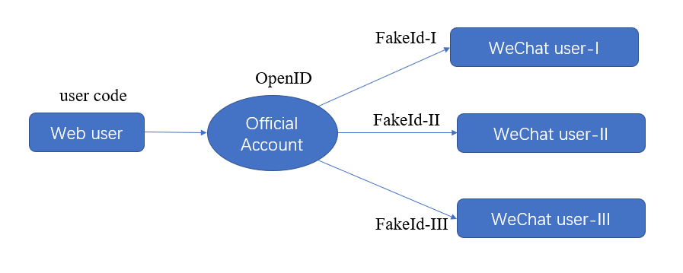

**Figure 5. binding process**

Besides, the OpenID of the official interface corresponds to the FakeId owned by each fan in the public platform, which was a function realized by a API and can implement the function of pushing information to specific users who bind information through a public account.

Given the connection between OpenID and system user code, we can find OpenId through user code and then find a certain FakeId through OpenID (See FigX). Here follows a code example to realize push important messages:

public static bool SendMessage(string Message, string fakeid)

{

bool result = false;

CookieContainer cookie = null;

string token = null;

cookie = WeiXinLogin.LoginInfo.LoginCookie;//get cookie

token = WeiXinLogin.LoginInfo.Token;//get token

string strMsg = System.Web.HttpUtility.UrlEncode(Message); //url encoding of passed information

string padate = "type=1&content=" + strMsg + "&error=false&tofakeid=" + fakeid + "&token=" + token + "&ajax=1";

string url = "https://mp.weixin.qq.com/cgi-bin/singlesend?t=ajax-response&lang=zh_CN";

byte[] byteArray = Encoding.UTF8.GetBytes(padate); // coding transform

HttpWebRequest webRequest2 = (HttpWebRequest)WebRequest.Create(url);

webRequest2.CookieContainer = cookie; //the cache when a user log in

webRequest2.Referer = "https://mp.weixin.qq.com/cgi-bin/singlemsgpage?token=" + token + "&fromfakeid=" + fakeid + "&msgid=&source=&count=20&t=wxm-singlechat&lang=zh_CN";

webRequest2.Method = "POST";

webRequest2.UserAgent = "Mozilla/5.0 (Windows NT 5.1; rv:2.0.1) Gecko/20100101 Firefox/4.0.1";

webRequest2.ContentType = "application/x-www-form-urlencoded";

webRequest2.ContentLength = byteArray.Length;

Stream newStream = webRequest2.GetRequestStream();

// Send the data.

newStream.Write(byteArray, 0, byteArray.Length);

newStream.Close();

HttpWebResponse response2 = (HttpWebResponse)webRequest2.GetResponse();

StreamReader sr2 = new StreamReader(response2.GetResponseStream(), Encoding.Default);

string text2 = sr2.ReadToEnd();

if (text2.Contains("ok"))

{

result = true;

}

return result;

}

# 8.0 Learning Analytic

## 8.1 What data do you need?

The original intention of this platform is to provide students with a platform to collect and save students' course works and notes, support various types and sources of display content, introduce the point incentive system, personalized recommendation works, break the boundaries of the grade, and build a learning community based on discussion, exchange and sharing. The discussion board as our core function is the focus of data collection. The specific data collected are as follows:

**Table 6. collected data**

|  |  |
| --- | --- |
| Functional areas | Data |
| Home page | When you enter the homepage, click the name, type and column of the works you browse, and see The Times of clicking, uploading works, personal center clicking, searching (content) and navigation bar module in the discussion area of different modules. (the homepage is mainly a collection of browsing and clicking times of some functions, in order to see which area is the hot area that students pay more attention to, in order to analyze students' preference of some functional areas) |
| Public discussion | Number of posts, content and time, check the content and category of posts, and pay attention to the preference of the list |
| Works | Search times, search contents, see specific work types, labels, content, related author labels, score levels, likes, comments, collection times |
| Courses | The number of clicks, content labels, labels of relevant authors, score levels, likes, comments, favorites, search content and times, as well as options for multi-level joint selection, and usage times |
| Course discussion | Content points, tags, number of likes, collections, sharing times, viewing status, whether the topic is concerned or not, the private message (number, content, time) or attention of the author of the work, the number of views (clicks) on popular recommendations, its Content, tags, time; number of times (like / reporting) to other people's comments, time, content (including their own responses and other people's comments), self-evaluation content, scoring, reviewer ratings and ratings. |
| Personal center | Pay attention to the number of clicks on the menu in each column and the navigation bar such as my post, the specific column name and time, the click on the message in the message center, the response, the number and content of personal specific information modifications. |

## 8.2 How will you capture that data?

Platform for data collection need to be carried out in accordance with the xApi specification, xApi "flow" is used to describe the learning experience, follow the flow specification Activities, defines how to generate and collect learning activity stream data, contains 3 elements are respectively the operator (Actor), action (Verbs), as well as learning experience related Activities (Activities), can form a group of the most concise activity stream format: < Actor, Verb, Object >. For this reason, we need to consider the users (operators) of the platform in advance, the behaviors (actions) that users may interact with the platform, and the functions provided by the platform (activities/objects), and conduct reasonable coding to form a set of tabular information so that the activity description can be matched later. The specific steps are as follows: first, describe the learning experience in the learning process, then turn the learning experience overview into a specific learning event by selecting appropriate actions, and finally map the learning event into a set of contextual statements to record the complete learning experience.

## 8.3 How will you structure the data?

The activity flow is the specification that xAPI follows to describe the learning experience, which eventually exists in the form of semantically structured data called a "Statement" that contains all the attributes of the learning experience, as shown in table 1. In addition to the xAPI specification, learning experience tracking requires a place to store these records, the learning records repository (LRS), where each statement will be recorded.

**Table 7. Statement key attributes**

|  |  |  |
| --- | --- | --- |
| Element | Explanation | Considerations |
| Actor | An identity of the person who did the thing. People often have multiple identities e.g. personal and work email, Twitter etc. Only one is assigned to the experience. | We are concerned about the behavior of students when using the platform, so the operators are mainly students. As for the study group function, the platform has not been realized yet, so the group behavior will be considered in the future. The identifier of the student should be unique, so that the identity of the student can be determined according to the identifier. As for the identifier of the activity, we will encode the possible interactive behaviors and functions of the platform in advance, and assign specific letters or Numbers to facilitate recording. |
| Verb | The action being done by the actor. | At present, some interactive actions involved only involve the mouse, keyboard and the system's own functions, such as the left and right keys of the mouse, the wheel, the keyboard, the opening and closing of the system platform, window monitoring and other operations, statements are only displayed in Chinese, verb translation is stored in the statement. |
| Object | The thing the actor is acting on. This is normally an activity, but can also be a person, group or even another statement. | About the object itself, you need to get the object's unique identifier, content, category, and operation time. Because there may be many objects of the same form in the platform, you can create unique ids for each object by category, group, and page. |
| Result | The outcome of the experience e.g. success, completion, score etc. | The discussion based on the work has the module of scoring, including the author who created the work needs to evaluate his own work, and the teacher will also score and post comments on the students' achievements in the discussion area. By discussing the difference between people's comments, the author learns from the communication, which is reflected in the enhanced interaction in the discussion area and the improvement of the score of the next work. The interaction of the discussion area will affect the role allocation of the discussion area, and the one with high number of likes will get the title of top role. The public discussion forum is not necessarily a discussion of the work, but it is also a glimpse into the quality and depth of the discussion from the number of thumb up posts and comments. |
| Context | The context of the experience, e.g. the larger learning activity this formed a part of, any other related activities, the instructor or team, the platform and language used in the experience. | Since it is a discussion board-based learning platform, the data in the course comment area and public discussion area need to be paid more attention to. For example, it is necessary to record the identification of the discussion area, contents contained, comments, etc., which page it is on, specific reply in the comment area, thumb up or topics of concern, etc. |
| Authority | The person or group that asserts that the thing happened. The authority is set by the Learning Record Store based on the security credentials used. | Platform default is including teachers, students, administrators and other three roles, the only temporarily meet students of all functions, the function of the platform of teachers on students' function increases the management of students, for example, to give students score, and other functions, the administrator has the user management, user rights assign, permissions, such as management works as a whole analysis information, control the normal operation of the whole display platform. |
| Timestamp | When the experience happened; not necessarily when the data was stored. | Data generally needs to be transmitted in real time. |
| Attachments | Files attached can be attached to the statement e.g. evidence of a learning activity. | The uploading of files is allowed, because there are curricular works submitted to the platform for comments and browsing by teachers and students. Due to some relatively large projects, such as video and audio clips, larger storage space should be allowed. |

The general structure of the data is as follows:

{

"version": "1.0.0",

"id": "33cff416-e331-4c9d-969e-5373a1756120",

"actor": {

"mbox": "mailto:example@example.com",

"name": "Example Learner",

"objectType": "Agent"

},

"verb": {

"id": "http://adlnet.gov/expapi/verbs/experienced",

"display": {

"en-US": "experienced"

}

},

"object": {

"id": "https://www.youtube.com/watch?v=xh4kIiH3Sm8",

"objectType": "Activity",

"definition": {

"name": {

"en-US": "Tax Tips & Information : How to File a Tax Return "

},

"description": {

"en-US": "Filing a tax return will require filling out either a 1040, 1040A or 1040EZ form"

}

}

},

"timestamp": "2013-04-01T12:00:00Z",

"attachments": [

{

"usageType": "http://adlnet.gov/expapi/attachments/signature",

"display": { "en-US": "Signature" },

"description": { "en-US": "A test signature" },

"contentType": "application/octet-stream",

"length": 4235,

"sha2": "672fa5fa658017f1b72d65036f13379c6ab05d4ab3b6664908d8acf0b6a0c634"

}

]

}

# 9.0 UX evaluation

## 9.1 Participant

Among the participants who completed the questionnaire effectively, there were 7 males, accounting for 25.9%, and 20 females, accounting for 74.1%. The major and grade distribution of participants is shown in the following table:

**Table 8. majors of participants**

|  |  |
| --- | --- |
| **Major** | **Num** |
| Electrical automation | 1 |
| Industrial and commercial management | 1 |
| Transportation engineering | 1 |
| Journalism | 1 |
| Application technology | 1 |
| Software engineering | 3 |
| Modern educational technology | 5 |
| Education technology | 13 |
| **Total** | **26** |

**Table 9. grades of participants**

|  |  |
| --- | --- |
| **Grade** | **Num** |
| College, senior year | 10 |
| Postgraduate, first year | 16 |
| **合计** | **26** |

## 9.2 Procedure

Our user experience measurement method draws on user experience questionnaire (UEQ) from Dr. Martin Schrepp. It is a seven-stage scale, the items are scaled from -3 to +3. Thus, -3 represents the most negative answer, 0 a neutral answer, and +3 the most positive answer. The UEQ contains 6 scales with 26 items: attractiveness, perspicuity, efficiency, dependability, stimulation and novelty. Before filling out the questionnaire, we let participants experience the high-fidelity model of our platform, and in the process, give answers to their questions. Then we distributed 27 questionnaires through questionnaires and recovered 27 questionnaires. In order to detect random or not serious answers, a simple heuristic is used. The idea is to check how much the best and worst evaluation of an item in a scale differs. After judgment, one questionnaire was eliminated, and 26 valid data were obtained. Finally, use the UEQ analysis tool to analyze the data.

**9.3 Result**

**Table 10. Reliability of each scale**

|  |  |
| --- | --- |
| **Scale** | **Cronbach alpha** |
| Attractiveness | 0.92 |
| Perspicuity | 0.47 |
| Efficiency | 0.77 |
| Dependability | 0.83 |
| Stimulation | 0.80 |
| Novelty | 0.75 |

The reliability test results show that the reliability of Attractiveness is very good (above 0.9), the reliability of Stimulation and Dependency is considered acceptable (0.8-0.9), the reliability of Efficiency and Novelty is valuable (0.7-0.8), however the reliability of Perspicuity is very low and needs to be modified.

**Table 11. Descriptive statistics**

|  |  |  |  |
| --- | --- | --- | --- |
| **Scale** | | **Mean** | **Std. Dev.** |
|  | Attractiveness | 1.474 | 0.79 |
| Pragmatic  （1.27） | Perspicuity | 1.106 | 0.79 |
| Efficiency | 1.394 | 0.89 |
| Dependability | 1.317 | 0.99 |
| Hedonic  （0.93） | Stimulation | 1.058 | 0.94 |
| Novelty | 0.808 | 0.98 |

From the descriptive statistics, it can be seen that the score of Attractiveness is the highest, and the score of Novelty is the lowest. This also reveals that we need to pay more attention to novelty when we make changes later. As for the scores of Pragmatic and Hedonic, Pragmatic got an average score of 1.27 and Hedonic got an average score of 0.93, which are both higher than 0.8, which is considered a positive result.

**Figure 10. Benchmark comparison**

Compared with existing values from a benchmark data set, we found that the scores of all dimensions of the platform have reached the average level. Nevertheless, we still hope to find more specific instructions for our subsequent revisions. So we have a look at the following figure.

**Figure 11. mean value per item**

Of the 26 items, two values are less than 0.8, which are Creative and Complicated, that is, we should enhance the creativity of the platform and simplify it.

In the last question, "If you have the freedom of individual voluntary choice, your willingness to use the platform is", the average score is 7.77 (out of 10), so we believe that our platform has received a relatively satisfactory evaluation.

# 10.0 Final design

## 10.1 what does it cost?

If you want to operate this platform, you may need some expenses. Please see the following table 12 for a detailed list:

**Table12. Cost list**

|  |  |  |
| --- | --- | --- |
| **No.** | **Part** | **Cost** |
| 1 | cloud server | 5000 yuan/year |
| 2 | WeChat certification | 300 yuan/year |
| 3 | operation team | ---- |

## 10.2 System Role Definition

System roles refer to external users or external systems that interact with the system. There are three types of external users on this platform, system administrators, teachers / teaching assistant s, and students. The permissions between the three are as follows.

**Table 13. User role permissions**

|  |  |
| --- | --- |
| **User role** | **Privilege description** |
| System administrator | Manage the entire system platform, with user management, user rights allocation, work management, discussion area management and other rights. |
| teacher / teaching assistant | With student user management; work management (find, browse, download, evaluate, upload, delete); discussion area management (create topics, participate in topics, guide discussions and delete discomforts); student learning evaluation management. |
| student | Work management (find, browse, like, collect, share and upload, delete personal works); Discussion area management (find, participate, like, follow, share and discuss various topics on the platform, delete personal topics and report discomfort Discussion); Participate in learning evaluation. |

## 10.3 System operating environment

**10.3.1 System operation network environment**

Both the client and the management user can log in to this system through the network (campus network, Internet). Students log in to the platform and register. After getting the administrator's review, they can enter the system to upload and delete works (limited to their uploaded works and published topic discussions), find, browse, comment, exchange discussions, participate in learning evaluation, etc. . Teachers / TAs log in to the platform and register. After getting the administrator's review, they can enter the system to upload, delete, browse, evaluate, and participate in topic discussions and exchanges. At the same time, they can manage student information and work information, and view reports of students' uploaded works. Wait. The administrator has the authority to manage all users.

**10.3.2 The system runs on the hardware environment**

Client: ordinary PC, tablet, smartphone.

**10.3.3 System running software environment**

Operating system: Unix, Linux, windows2000 or above.

**10.4 Client Core Function Module Design**

The client, also known as the client, is a party that receives services from the system, and is also the most core module that the system needs to develop. Figure 12 is the design diagram of the student-side core function module developed in this project.

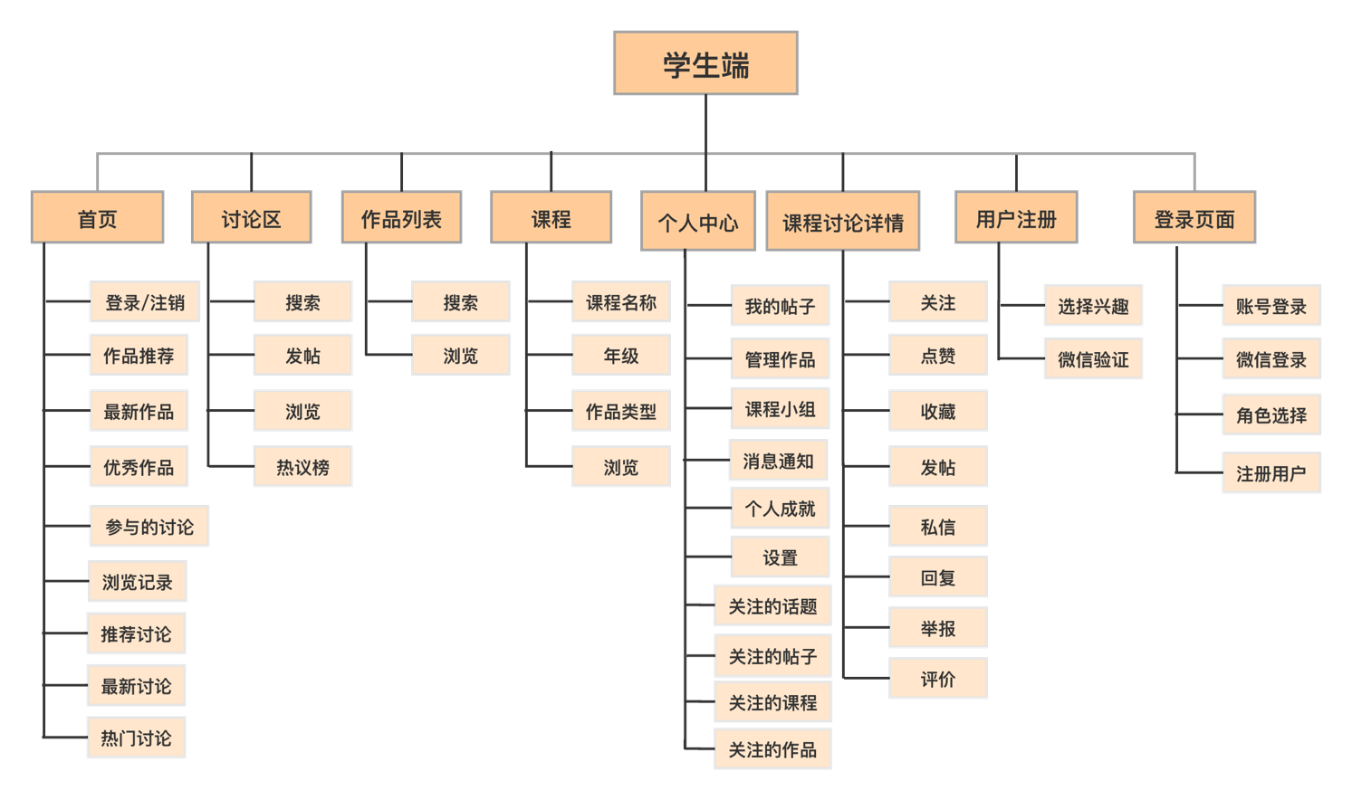

**Figure 12. Student side function**

**10.5 Use case analysis**

1) How to provide different users with interesting types of works?

|  |  |  |
| --- | --- | --- |
| **Program** | **Functional Module** | **Steps** |
| User-selected topics of interest | Register | Select Interest Module | Students choose their own type of interest |
| Personalized analysis | System analysis | (1) The system analyzes the types of works that users participate in reviews, likes, and collections;  (2) Recommend outstanding works with high ratings |

2) How to improve the quality of discussions and the enthusiasm of student participation？

|  |  |  |
| --- | --- | --- |
| **Program** | **Functional Module** | **Steps** |
| Discussion area role control | System analysis | Opinion leader, label (review advanced, review intermediate, review junior) |
| Discussion guide | Teacher / TAs / Administrator | Forum Management | Lead forward discussions (TA guidance, teacher management) |
| Discuss Post Tags | System analysis | Cross-grade participation such as quality discussions, teacher participation, teaching assistant participation, 2015 participation |
| Delete inappropriate posts in a timely manner | System Analysis, Teacher / TAs / Administrator | Forum Management, Student | Report | Intelligent monitoring, administrator / teacher monitoring, student reporting |
| Setting up a reward mechanism | System analysis | System analysis |
| Private chat users | Student | Discussion Board Management | Cross-grade learning exchange opportunities, teacher-student exchange opportunities |
| Live chat feedback | Automatically processed by the system | Bind to WeChat public account, prompt reminder reply via public account |

3) How to let users quickly search for works？

|  |  |  |
| --- | --- | --- |
| **Program** | **Functional Module** | **Steps** |
| Resource classification | Admin | Work Category, Student | Upload Work | When users upload works for their own classification-works type, grade, course, the administrator is responsible for review |
| Sort resources | Automatically processed by the system | Sort by various rules-release time, optimal, number of discussions, number of favorites, etc. |

4) How to realize the combination of multiple learning methods？

|  |  |  |
| --- | --- | --- |
| **Program** | **Functional Module** | **Steps** |
| Self-learning | Student | Discussion Board Management | Through the platform, students can independently search and observe outstanding works. |
| Collaborative learning | Students | Discussion Board Management, Teachers / TAs | Discussion Board Management | Students and teachers, students and students can initiate topics for discussion and exchange in the discussion area, or private messages |

5) How to manage users？

|  |  |  |
| --- | --- | --- |
| **Program** | **Functional Module** | **Steps** |
| Automatic import | Administrator / Teacher / TAs | User Management | Automatically import student information |

6) How to manage works？

|  |  |  |
| --- | --- | --- |
| **Program** | **Functional Module** | **Steps** |
| Student upload review | Administrators / Teachers / TAs | Work Management | When users upload works, they must first review the classification. Has anyone uploaded the same work? |
| Works deleted | Administrator / Teacher / Teacher | Work Management, Student | Report | If the same or inappropriate work is found, the administrator / teacher / tutor | work management to delete the work; students can also report |

7) Student-side use cases

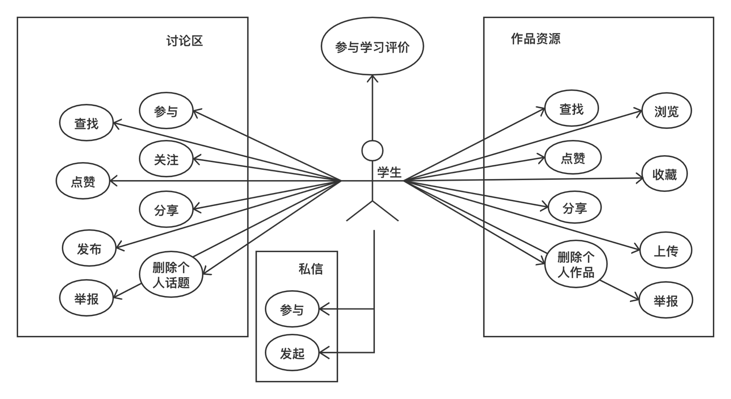

**Figure 13. Student side use cases**

# 11.0 Conclusions

Since the implementation of the project, innovation points have been proposed based on demand analysis of similar products, platform design based on learning theory, and feasibility analysis based on technology. Finally, user experience and overall design of the project have achieved the desired effect. But because of time, we only finished the prototype of the "student side".

|  |  |
| --- | --- |
| Envision/function | implementation |
| Works management (search, browse, thumb up, collect, share and upload, delete personal works); | Yes |
| Discussion area management (search, participate, thumb up, follow, share platform for various topics of discussion and release, delete personal topics and report inappropriate discussion); | Yes |
| Participation in learning evaluation | Yes |
| Adaptive recommended work/discussion | Yes |
| Data acquisition and learning analysis | Yes |
| Prompt response (WeChat binding) | Yes |
| incentives | Yes |
| Personal space | Yes |
| The operation is simple | Yes |
| The interface is beautiful | Yes |
| Student/teacher/assistant/administrator authority allocation | Yes |

# References

张晶婵. (2019). 美术作品管理实践与研究--以山东美术馆为例. 行政事业资产与财务, (5), 10-12.

罗少君. (2015). 中职学校学生美术作品管理及评价系统的设计与实现 (Master's thesis, 华南理工大学).

郭庆春, 侯翠萍, & 孙鹤. (2012). 基于 ASP 的 Flash 作品管理系统设计与实现. 电脑编程技巧与维护, (16), 167-168.

刘仲, & 朱海滨. (1998). 基于 OLE/COM 的多媒体作品管理系统 (Doctoral dissertation).

史蒙蒙. (2018). 基于社会认知视角的虚拟学习社区成员知识共享行为影响因素研究. 中国集体经济, (15), 54-55.

化得福. (2014).论罗杰斯的人本主义教育思想.兰州大学学报: 社会科学版,42(4),152-155.

潘光花. (2017). 西方三种学习理论对当代教育教学的启示. 学理论, (5), 198-199.

苏莉. (2019). 人本主义视角下导学教师的角色与目标定位. 广西教育学院学报, (3), 14.

雷钢. (2010). 人本主义学习理论对教育技术的新启示. 中国电化教育, (6), 30-33.

张驰, 刘海骅, 练宸希, & 李婧. (2019). 人本主义视角下和谐导学关系的重构. 现代教育管理, (7), 107-111.

刘小雪. (2012). 基于 Web 使用挖掘的 e-Learning 自适应推荐系统. 电化教育研究, (4), 82-84.